Personal Cybersecurity Lab

By:
R Sharan Kumar

1. Objective
- The objective of this task is to build a safe and isolated cybersecurity practice environment on a local machine.
- This environment will serve as a foundation for future work in vulnerability assessment, web application testing, exploitation practice, and incident response.
For this lab I created:
- One attacker machine running Kali Linux
- One vulnerable web application (OWASP Juice Shop or DVWA)
- A segmented network using NAT and Host-Only adapters to keep testing traffic isolated

2. Lab Design and Skills
2.1 Architecture
High-level design:
- Host system: My physical laptop/desktop
- Virtualization platform: VMware Workstation / VirtualBox
- Attacker VM: Kali Linux
- Target VM / Service: Juice Shop or DVWA
- Networks:
  - NAT: For internet access (updates, package installs)
  - Host-Only: For private traffic between attacker and target
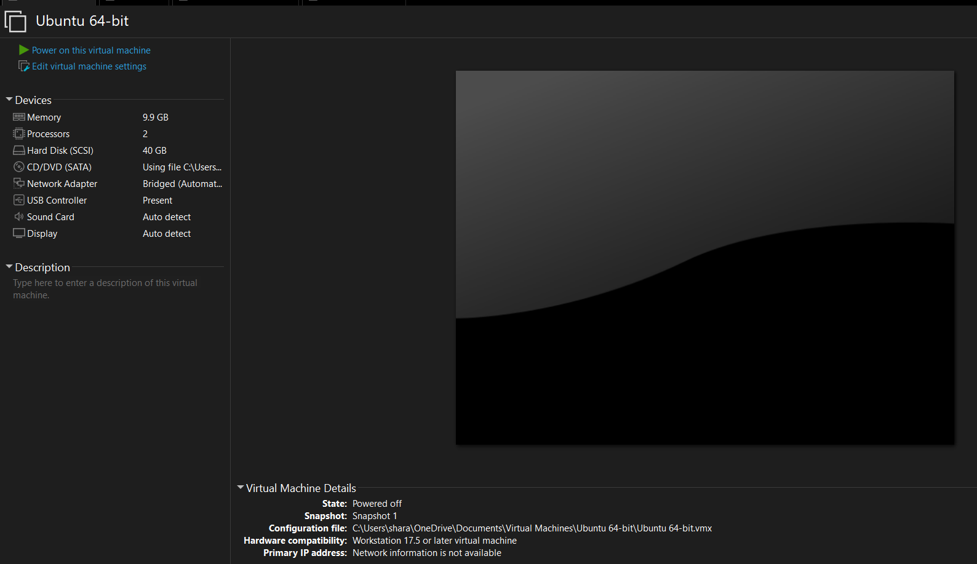
2.2 Skills and Outcomes
This lab demonstrates:
- Virtualization – running multiple isolated virtual machines for penetration testing
- Lab isolation – ensuring real systems are not affected by attacks
- Web targets setup – deploying intentionally vulnerable applications
- Basic networking – understanding NAT vs Host-Only networks and subnets
- Tool awareness – using Nmap, Burp Suite, and Wireshark to validate and observe traffic
3. Prerequisites and Software
3.1 Host Requirements
- RAM: at least 8 GB (16 GB recommended)
- Disk space: 40–60 GB free
- CPU: supports hardware virtualization and has it enabled in BIOS/UEFI
- Operating system: Windows / macOS / Linux
3.2 Software Used
- VMware Workstation Player / VirtualBox
- Kali Linux virtual machine image
- OWASP Juice Shop or DVWA source
- Docker Engine (if using Juice Shop in a container)
- Burp Suite Community Edition
- Wireshark
4. Virtual Machines and Network Layout
4.1 VM List
VM Name | Role | OS / Version | Network Adapters | Notes
Kali-Attacker | Attacker | Kali Linux (x64) | Adapter 1: NAT; Adapter 2: Host-Only | Runs Nmap, Burp, Wireshark
Target-Web | Target | Ubuntu / Debian + Juice Shop or DVWA | Adapter: Host-Only | Hosts vulnerable web app

4.2 Network Configuration (Hypervisor)
Explain how you configured networking:
- Created/used one NAT network for internet access
- Created/used one Host-Only network for isolated lab traffic
- Kali: two adapters → NAT + Host-Only
- Target: one adapter → Host-Only
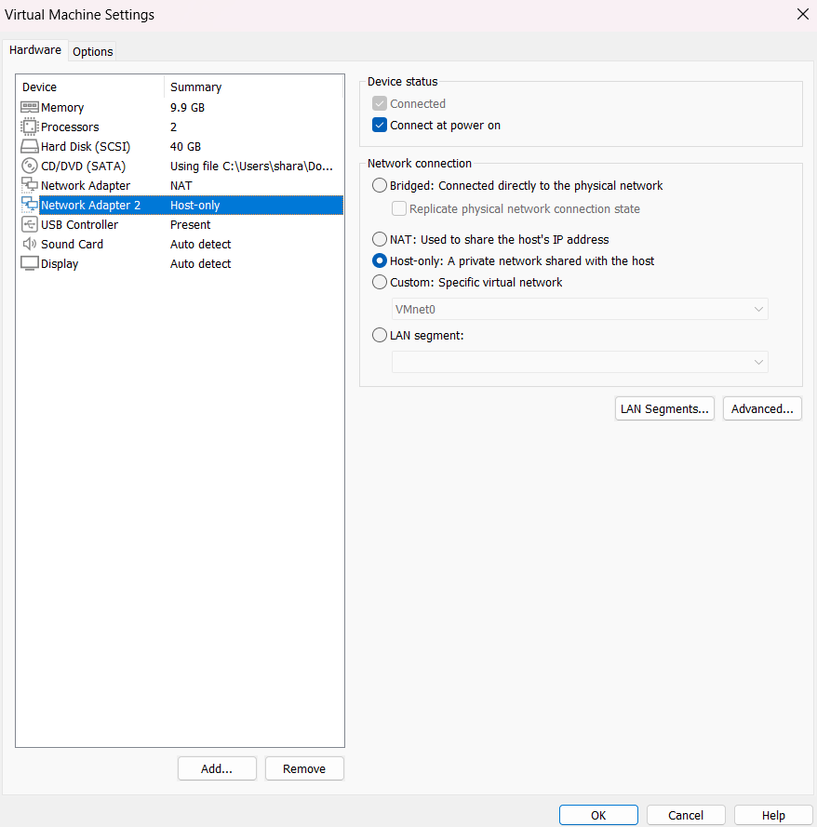

4.3 IP Addressing Inside the VMs
Show how the addressing looks from inside the VMs.
Example (adapt to your real IPs):
- Kali
  - eth0 (NAT): 192.168.222.134
  - eth1 (Host-Only): 192.168.56.132
- Target
  - Host-Only interface: 192.168.56.140
- Juice Shop (Docker bridge): 172.17.0.1 / 172.17.0.x
Commands:
On Kali
ip a

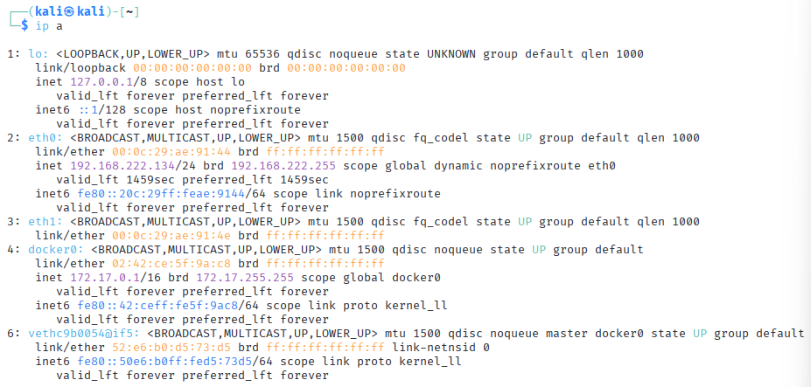

5. Target Deployment
5.1 OWASP Juice Shop (Docker example)
If you chose Juice Shop, document the deployment steps:
sudo apt update
sudo apt install -y docker.io
sudo systemctl enable --now docker
sudo docker pull bkimminich/juice-shop
sudo docker run -d -p 3000:3000 --name juice bkimminich/juice-shop
Explain:
- The container listens on port 3000.
- From Kali you will access http://<target-ip>:3000/ or http://172.17.0.1:3000/ depending on your routing.
6. Connectivity and Nmap Validation
6.1 Basic Connectivity
Show that Kali can reach the target over the Host-Only network.
Commands:
# From Kali
ping <target-host-only-ip>
Explain:
- Packet loss should be 0%.
- This confirms L3 connectivity between attacker and target.
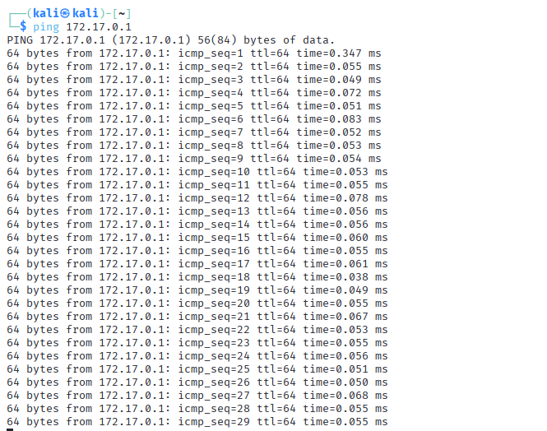

6.2 Nmap Scan
Run Nmap from Kali to confirm the host is up and discover open ports.
Examples:
# Host discovery
nmap -sn 192.168.56.0/24

# Service/version scan against the target
nmap -sV <target-host-only-ip>
Explain the findings briefly:
- Nmap detects the target IP as “host up”.
- It identifies the HTTP port in use (80 for DVWA, 3000 for Juice Shop).
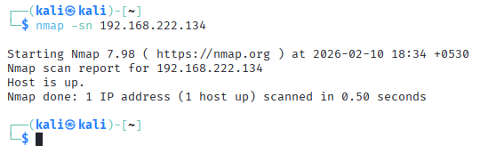
7. Web Application Access
Demonstrate that the vulnerable web app is reachable from Kali’s browser.
Examples:
- Juice Shop: http://172.17.0.1:3000/ or http://<target-ip>:3000/
- DVWA: http://<target-ip>/dvwa/
Write a short description:
- The homepage loads successfully.
- This proves the app is running and accessible over the lab network.
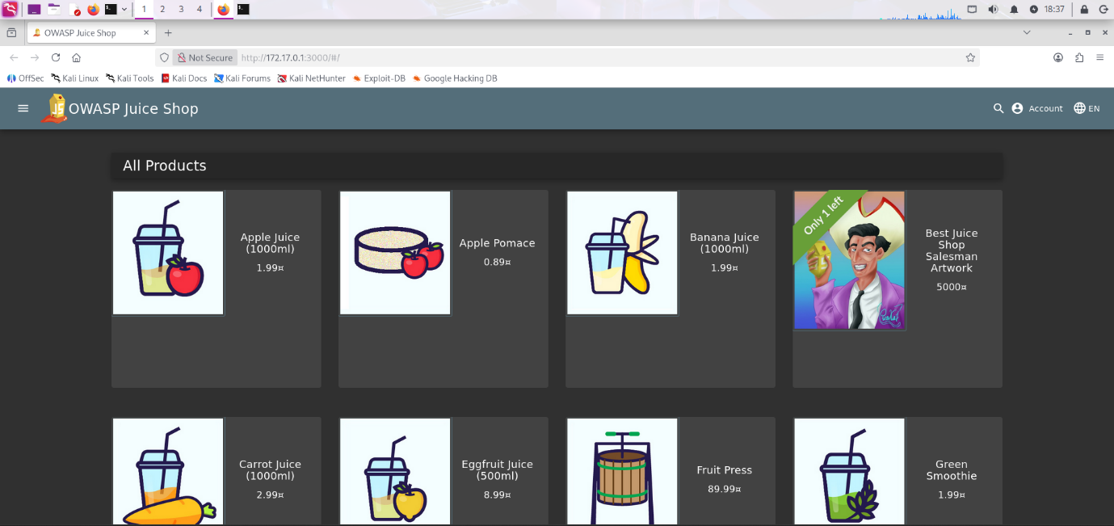

8. Burp Suite Validation
Describe how you used Burp Suite as an intercepting proxy.
Steps:
- Start Burp Suite Community Edition on Kali and create a temporary project.
- In the browser on Kali, configure the HTTP proxy to:
  - Address: 127.0.0.1
  - Port: 8080
- Enable “Intercept is on” in Burp.
- Visit the Juice Shop / DVWA URL again.
- Observe HTTP requests appearing in Burp’s Proxy → Intercept or HTTP history tab.
Explain:
- This confirms that you can intercept and inspect web traffic between Kali and the target.
- Burp will be used later for web application testing.
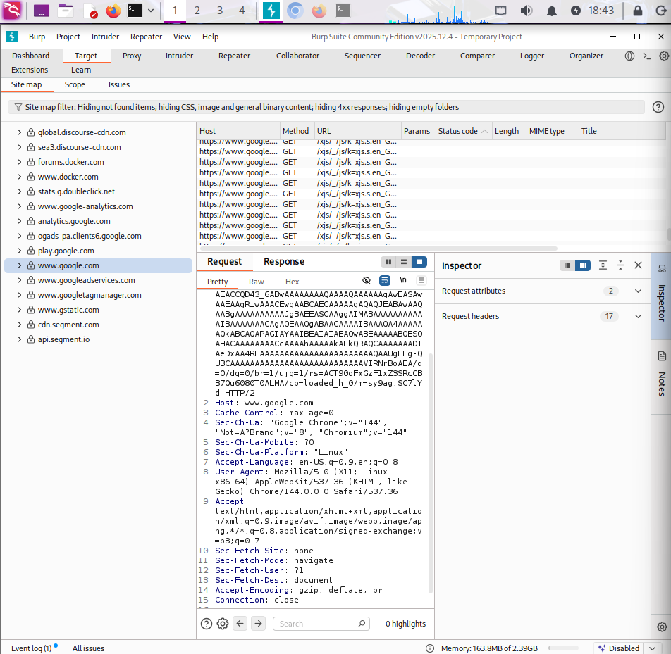

9. Wireshark Traffic Capture
Explain how you captured traffic at the packet level.
Steps:
- Launch Wireshark on Kali.
- Select the network interface that carries lab traffic (Host-Only or Docker bridge).
- Start a capture.
- While capturing, browse the target web app from Kali.
- Optionally apply a filter such as:
  - ip.addr == <target-ip> or
  - tcp.port == 3000 or tcp.port == 80
Document:
- You can see TCP packets between the attacker and the target.
- Following a stream reveals the HTTP request and response data.
